**Quran App**

## Admin Dashboard

1). Admin can Create/update/delete the Groups. ( need multi admin 2 or 3 each has user name & password)  
The Group Form will have Following Fields  
what do you mean by groups , all classes are individual ( one to one ) not a group of students

|  |  |
| --- | --- |
| Fields Name | Type |
| ID | Int (Auto Increment) |
| Name | Single line Text |

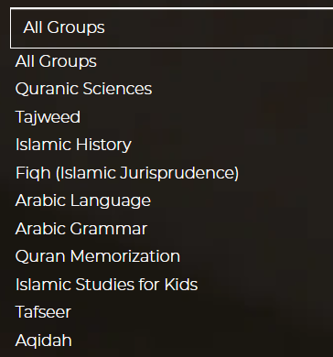  
E.G (are these types of services ? will send you total types of services )

Need mails at domain of our website for each student / teacher / supervisor / admin .

2). Only admin can Create/update/delete the tutors/teacher

The Tutor Form will have following Fields

|  |  |
| --- | --- |
| Fields Name | Type |
| ID | Int (Auto Increment) |
| Name | Single line Text |
| Contact | Int |
| Email | Single Line Text |
| Password | Single lineText |
| Confirm password | Single Line Text |
| Degree | Single line Text |
| City | Single line Text |
| Country | Single line Text |
| Groups????? | Multiselection - Dropdown (Group will be filled by another form) |
| About | Multiline Text |
| Work Experience | Multiline Text |
| Certificates |  |

Each teacher has calendar for schedule of classes

Each teacher has follow up sheet with her students (will send you sample of sheet )

Each teacher only see her students ( not allow all student information only the needed course)

Teachers not see each other ( teacher has 2 channels up channel with supervisor /admin and other channel with her student )

3). Admin can Create/update/Delete courses.

The courses Form will have following Fields

|  |  |
| --- | --- |
| Fields Name | Type |
| ID | Int (Auto Increment) |
| Name | Single line Text |
| Tagline | Single line text |
| Thumbnail | Picture |
| Description | Multiline text |
| Total Number of Classes | Int |
| Number of classes per week | Int ( list from 1 to 7 ) |
| Course Price | Int |
| Class duration | **30 min / 45 min / 60 min** |

**We need Supervisor account that only follow students /teachers / courses and follow payment but has not permissions like admin.( create /update /delete ).**

**Supervisor will select the suitable teacher for each student. And link them**

4). Admin & **supervisor** can see the list of Student and can see their progress

5). Admin & **supervisor** have rights to see their tutors list at once.

6). Admin & **supervisor** can see their payment received amount and which student pays how much amount according to date wise

7) Admin & **supervisor** will see the enrolled courses list of student.. and will manually assigned tutor to it.

8). Each and every process of the web app will include email

## Student Dashboard

1). Student will be sign up from the website **please find the registration form**

The Student Form will have following Fields

|  |  |
| --- | --- |
| Fields Name | Type |
| ID | Int (Auto Increment) |
| Name | Single line Text |
| Father Name | Single Line Text |
| Contact | Int |
| Email | Single Line Text |
| Password | Single lineText |
| Confirm password | Single Line Text |
| City | Single line Text |
| Country | Single line Text |

2). Student can see their enrolled courses, **individually**

3). Student can see the remaining classes of courses

4). Student can see the progress of courses

5). Student can see the paid amount of their courses

6). Student can ask question from their tutor

7). Student can see their assigned tutor

8). Student can give Feedback after the completion of whole course or **after the class**

9). Each and every process of the web app will include email ok

## Tutor Dashboard

1). Tutor can see their assigned students and their courses **individually**

2). Tutor can share their zoom or skype id to student.

3). Tutor can give feedback after each class in text form .**Sheet form I will Send you**

4). Tutor can manage their student and their asked questions ( **only technical Questions ) and supervisor can see this questions.**

5). Each and every process of the web app will include email.

**6) Teacher will add class confirmation that done then the Fees of teacher increase automatically by the value of the class then by end of month each teacher has the amount salary**

## Website

Website will have landing page/home page, Courses page, About Page, Testimonial Page, How this platform works, Faqs, Terms of Services, Contact/Support Page.

Registration Page , hyper link with social media ( Facebook page , LinkedIn page ….) , need to add library page ( books and videos )

There will be Paypal integration in this system,